**STUDENT MANAGEMENT SYSTEM USER MANUAL**

**Table of Contents:**

1. Introduction
2. System Requirements
3. Startup

* Homepage/Courses
* Teachers
* Students
* Subjects
* Grades

1. Introduction

The Student Management System web application is intended to provide the user with a way to track student records, teacher records, updating-creating-deleting classes, subjects, students, teachers etc. The UI have many sections on which user can go and update the mentioned respective details. The user can add students/subjects/teachers/grades to the system, modify existing details, or select detail to remove from the system.

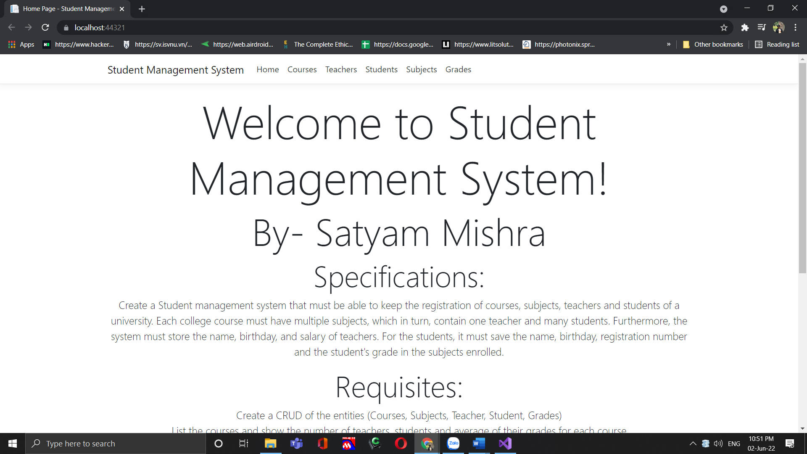

1. System Requirements

The application is compatible with all Linux, macOS, Windows Console, Cloud, and web.

1. Startup

* HomePage/Courses: Click on courses to see the list of courses.

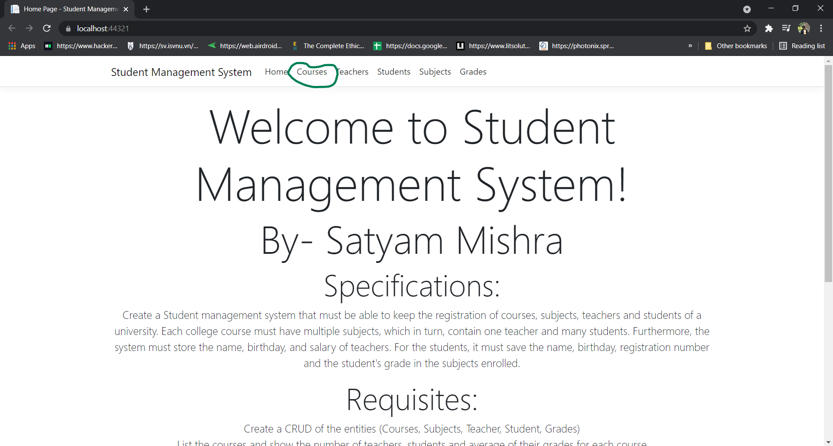

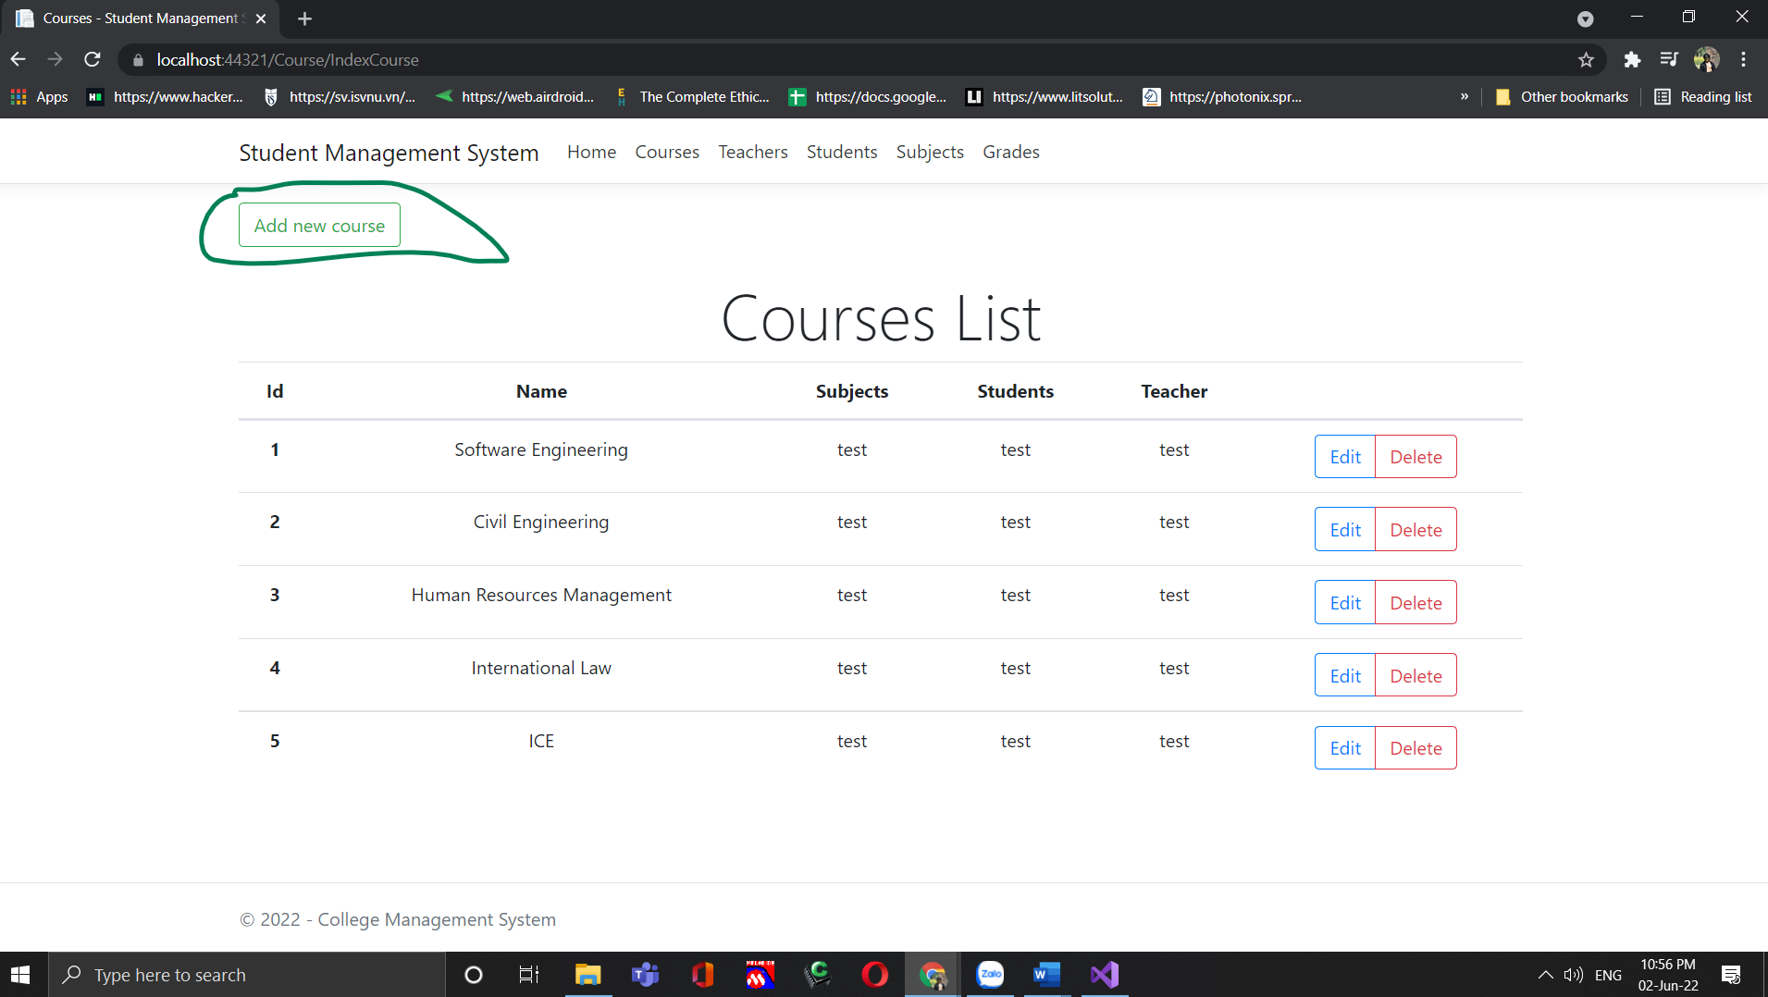

* Add New Course: To add new course on system, click on Add new course:

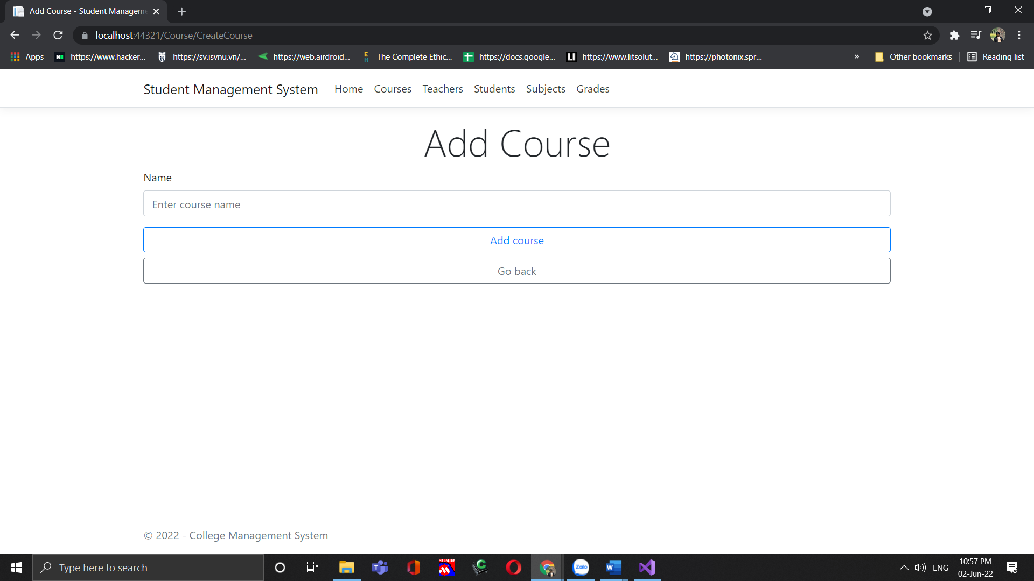

Now you can add the new course through this.

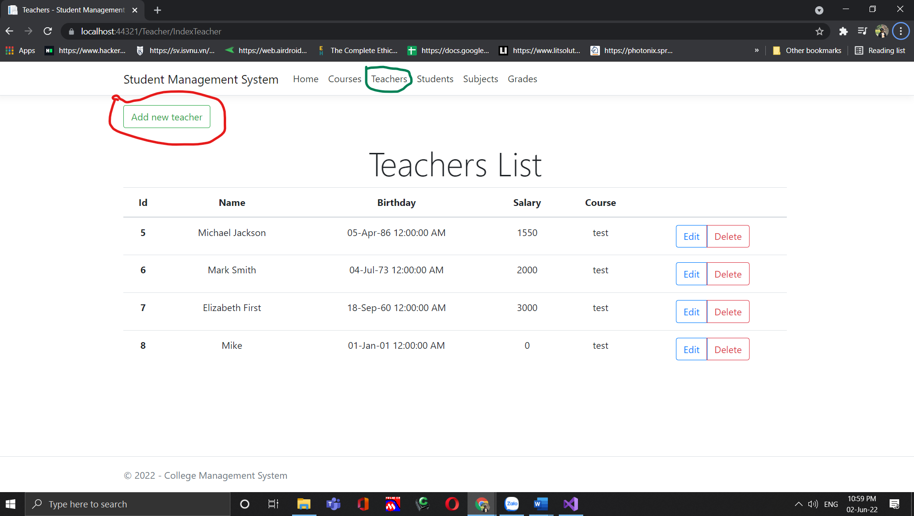

* Teachers- Click on Teachers to see the list of teachers on the system and then user can click on add new teacher if user wants to add new teacher.

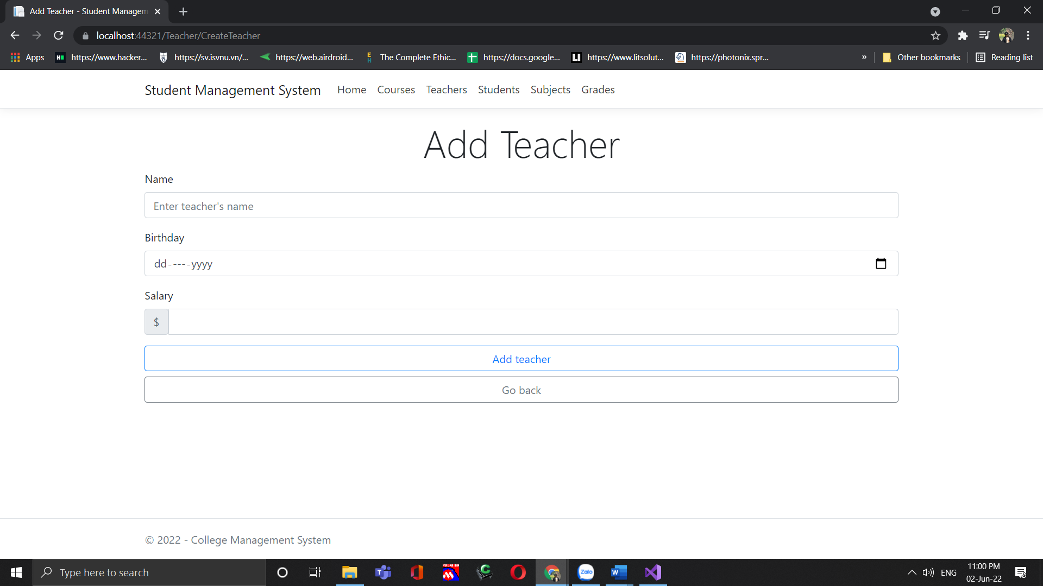

* User can fill in the new details of the new teacher and update it on the system.

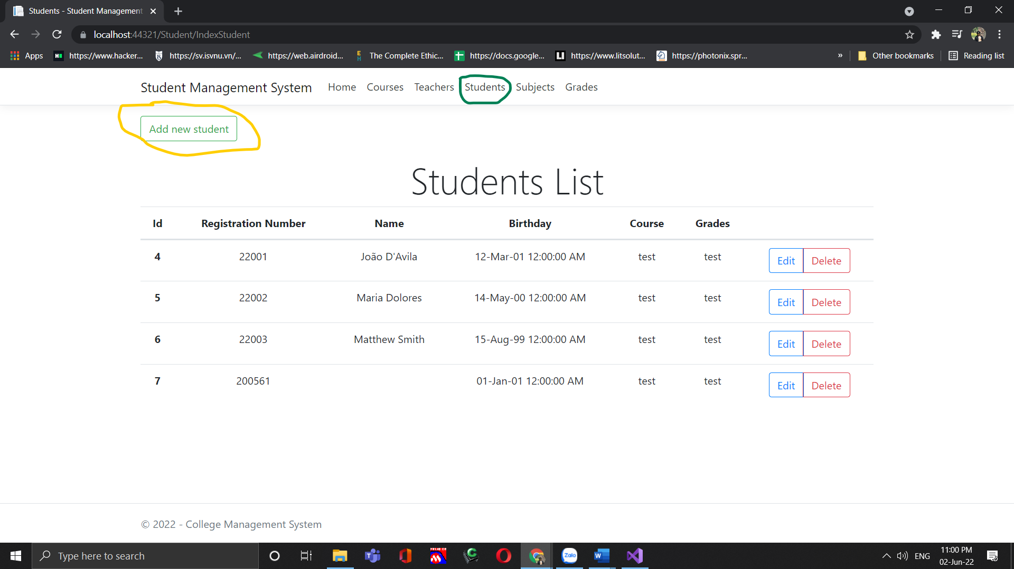

* Students- User can click on Students to see the students list and later if needed can add new student by clicking on Add new student button.

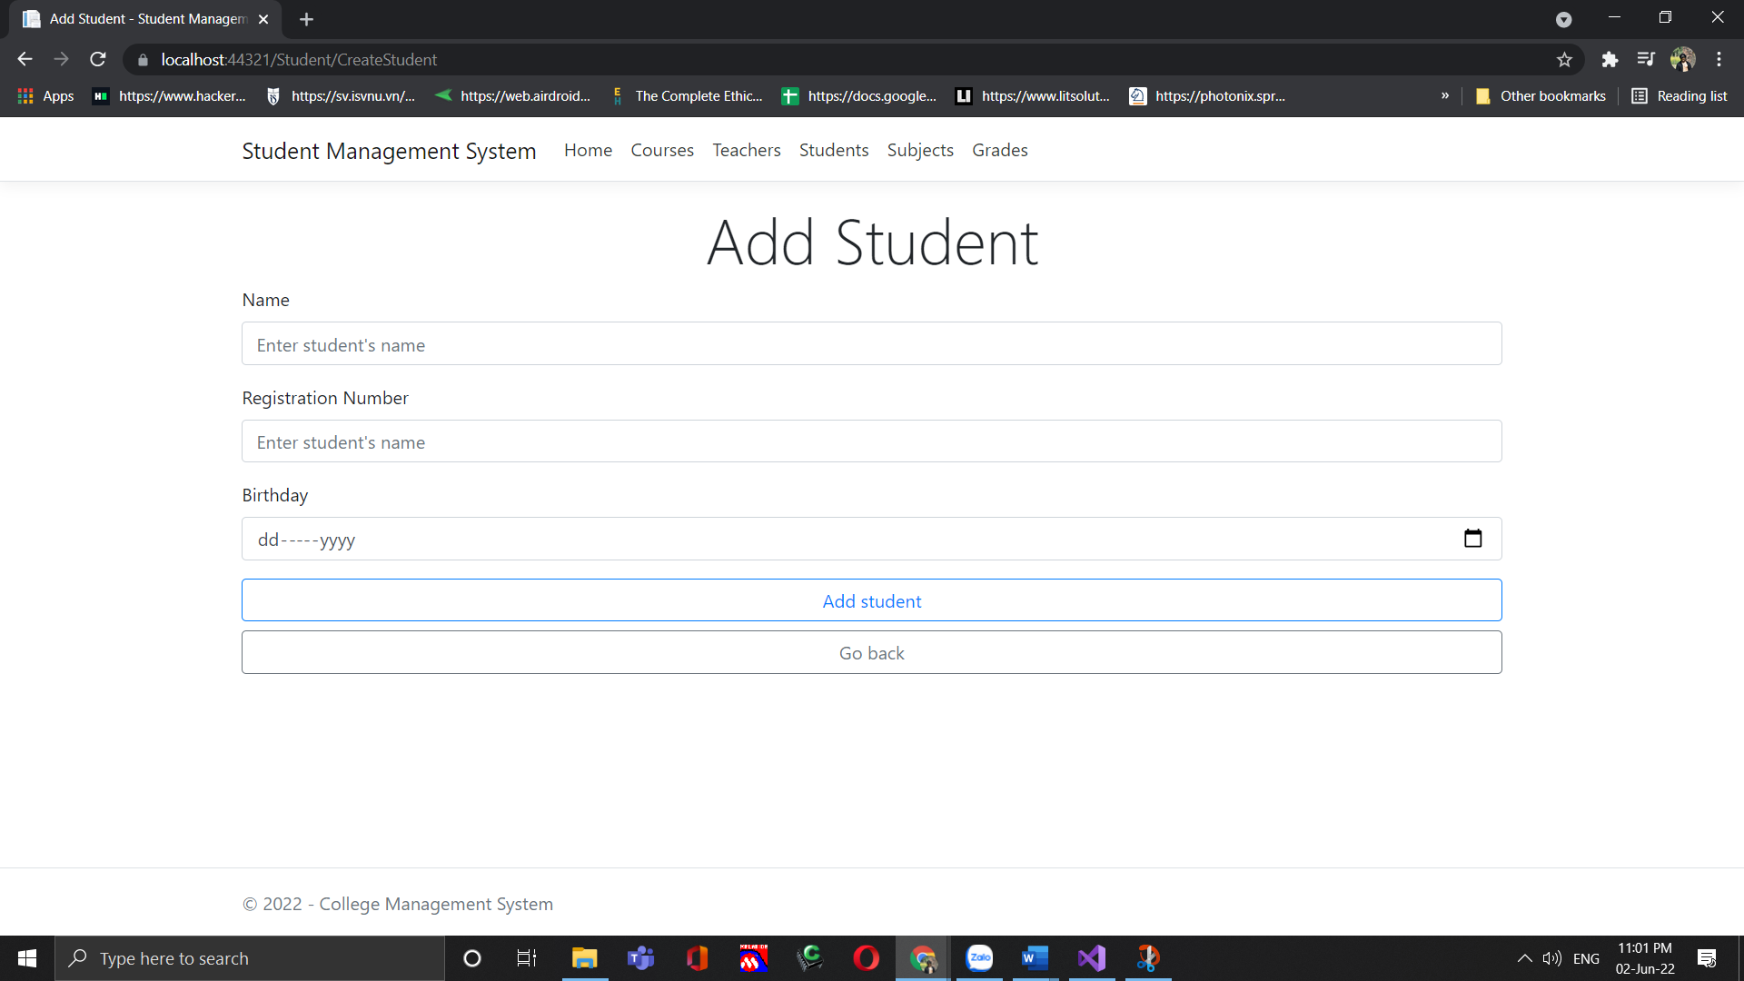

* User can fill in the details of new students and add it to the system.

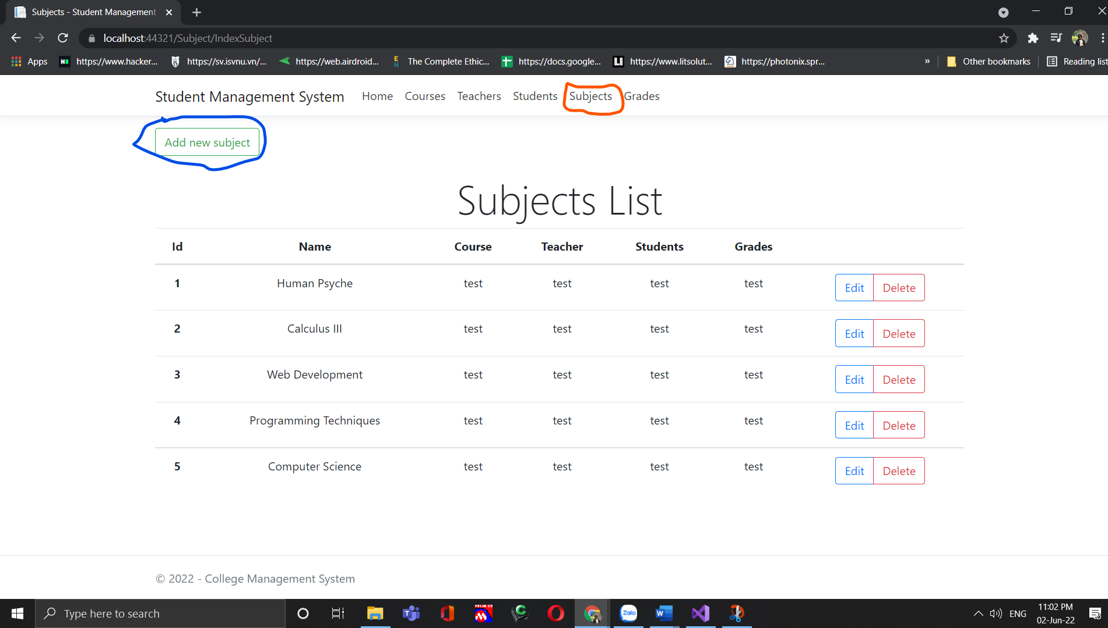

* Subjects- User can click on Subjects to see the subjects list and later if needed can add new subject by clicking on Add new subject button.

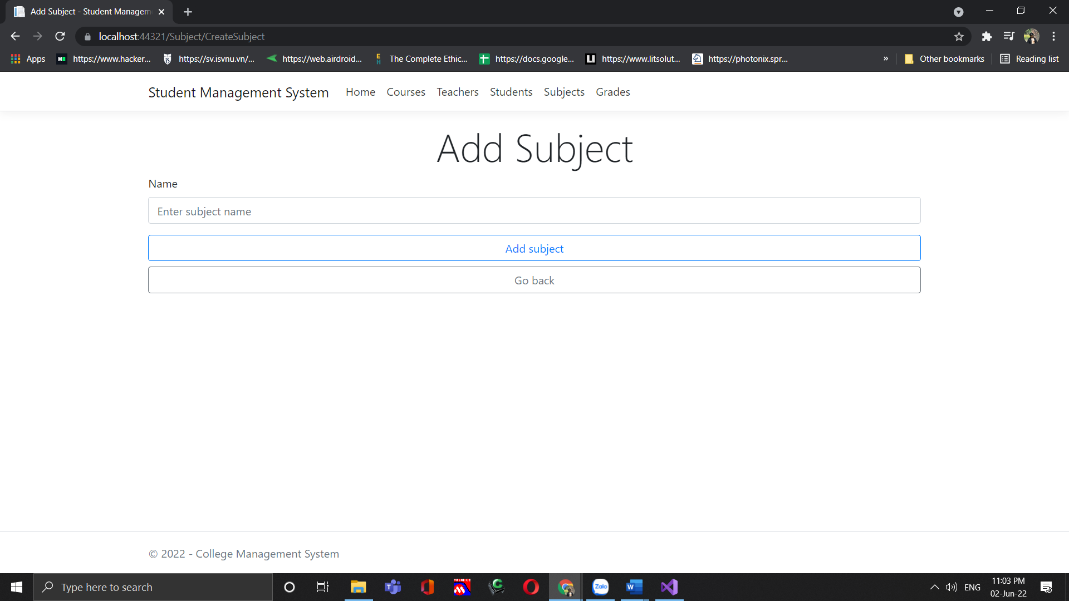

* User can fill in the details of new subjects and add it to the system.

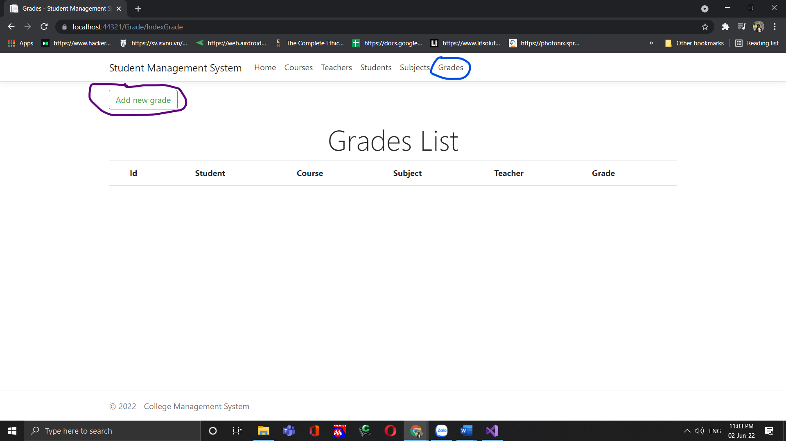

* Grades- User can click on Grades to see the grades list and later if needed can add new grades by clicking on Add new grade button.

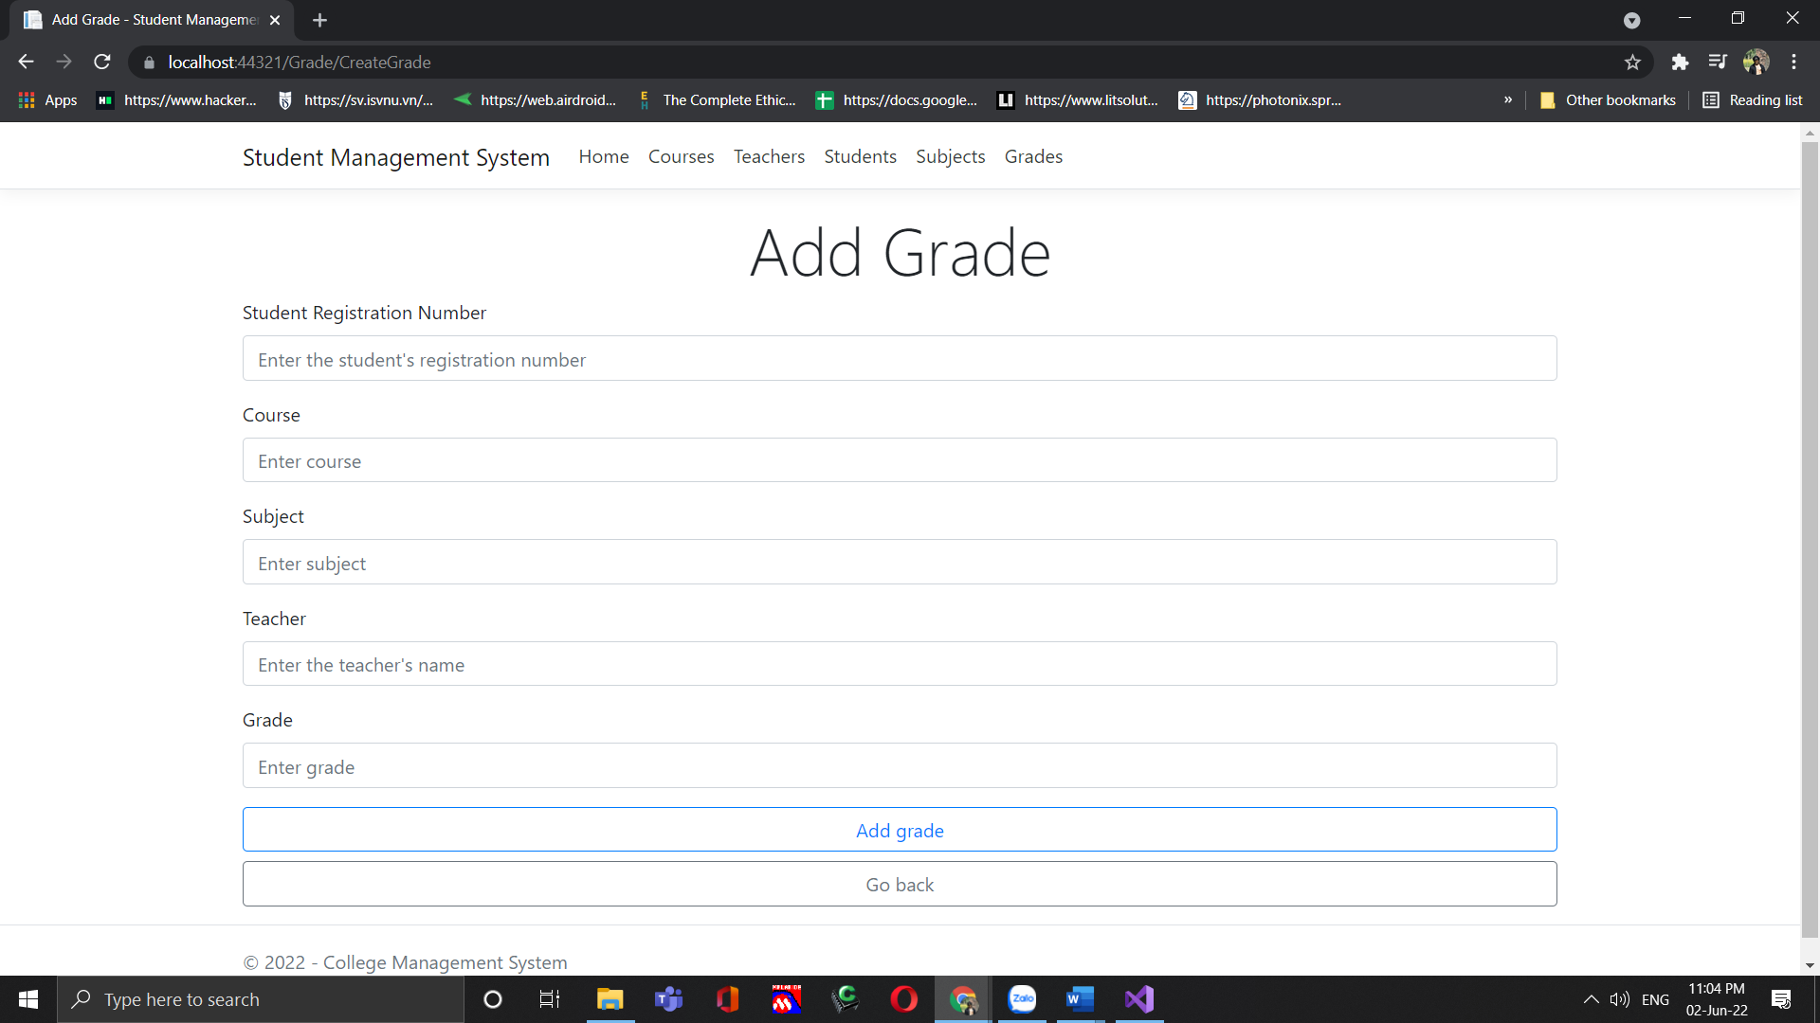

* User can fill in the details of new grades and add it to the system.